24 March 2020
Dear Parents and Caregivers,
I am writing to update you on the ongoing response to the novel coronavirus COVID-19 across the education sector.
These are unprecedented times for schooling systems and you can be assured that all Queensland state schools are working closely with the Department of Education as we respond to this significant and evolving public health issue.
Thank you for your support and understanding our school and the broader education community manage the impact of COVID-19.
I also acknowledge the excellent work being done by teachers and support staff in our school in ensuring your children are safe and continuing their learning during this difficult time.
School operations
As you may have heard in his press conference on 22 March 2020, the Prime Minister reiterated the view that schools are an essential part of our community and should remain open. This continues to be the advice of Australia’s chief health officers.
Leaders agreed that we cannot see children lose up to an entire year of their education as a result of possible school closures caused by COVID-19.
From Tuesday 24 March, Queensland state school parents and caregivers will be offered a choice as to how their children receive their learning.
State schools will remain open and parents and caregivers can send their children to school in the knowledge they will be safe.
If, however, you wish to keep your children home from school, you may do so. If you choose to keep your children at home, learning materials will be available on the Department of Education’s new learning@home website (qld.gov.au/learningathome). This website has downloadable learning materials, tips for parents and links to other well-regarded, free education websites that parents and caregivers and their children can use.
If you choose to keep your child at home, you must be responsible for them. You must ensure they stay at home and that they continue their learning using the material and websites that you can access online.

Student attendance
As is always the case, I ask parents and caregivers to let our school know if your child will not be attending school, for how long and the reason why.
If you choose to keep your child home due to concerns about COVID-19 you can be assured that you have made an acceptable decision.
You may have seen media reports last week that claim Education Queensland is ‘cracking down’ on parents who choose not to send their children to school due to COVID-19 concerns and that you are risking prosecution if you have made this decision.
The Department of Education has assured all schools that this is incorrect.
As outlined above, if you choose to keep your children at home, you can access materials available on the department’s learning@home website (qld.gov.au/learningathome) or other websites with curriculum materials. These materials have been available from the department for times when children have not attended school for extended periods.
School routines
As you would be aware, schools have been asked to change routines and some specific planned activities over the last few weeks to assist in managing the spread of COVID-19.
These include:
- ceasing all international school/departmental travel for students and teachers;
- postponing or cancelling external school activities such as fetes, concerts, fairs, etc.;
- in schools of greater than 500 students, stopping full school assemblies, arranging staggered lunch breaks where possible and rescheduling other large in-school student gatherings and events.
Schools have also been asked to postpone or cancel all school trips, camps and excursions including interschool and representative school sport competitions as a further step in reducing the risk of transmission in our schools and communities.
School hygiene
I can assure all parents and caregivers that during this time we are paying close attention to the cleaning of our schools. Queensland schools have excellent, dedicated cleaners and the department has provided them with additional advice on cleaning techniques since the onset of COVID-19.
To support this work the Government has also increased the amount of cleaning in Queensland state schools in response to the COVID-19 outbreak.
Our schools will be able to provide additional time to cleaners to enable them to pay extra attention to high touch point surfaces such as door handles, light switches, desks, toilets, taps and sinks.
Teachers at our school have also been focusing on the importance of effective hand and sneeze/cough hygiene with students.
Parents and caregivers can also access this information, which includes Queensland Health’s Six Steps to Successful Handwashing available at www.health.qld.gov.au/__data/assets/
pdf_file/0020/444314/handwash-6steps.pdf posters and a 20 second routine video that you can watch with your children, which is available at www.youtube.com/watch?v=Npm
B80pWUsk&feature=youtu.be.
Thank you
I sincerely thank parents and caregivers for the support you are giving your children and for the understanding you are showing to our school staff as they respond to this unique situation. It is important we continue to ensure our schools are safe and positive places for our children during these challenging times.
As always, the health and wellbeing of your children, and our staff, remain our focus.
We continue to take advice from Queensland Health in relation to this matter and the latest information is available on the Queensland Health website at www.qld.gov.au/health/
conditions/health-alerts/coronavirus-covid-19.
It is likely that these circumstances will be in place for many months ahead and we will all continue to work together in the interest of our schools and our school communities.
Yours sincerely
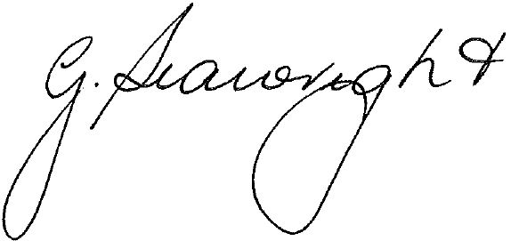
Glenda Seawright
Principal

